Oracle Apex – Interface Design

Application Builder (AB): Forms, Reports and Dashboard

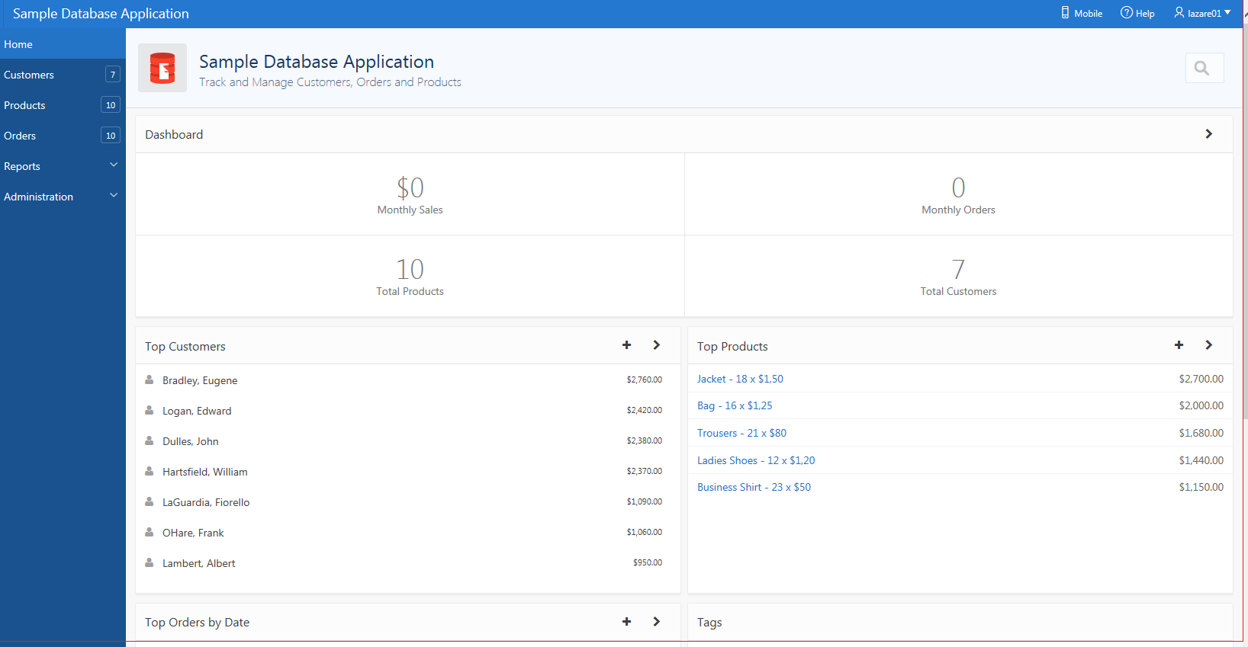

Oracle Documentation – visit

AB version 19.1 https://docs.oracle.com/en/database/oracle/application-express/19.1/aetut/oracle-application-express-tutorial-building-application.pdf

AB Version 20 https://apex.oracle.com/en/learn/documentation/

Contents
1. How to Build a Database Application 4
Creating Forms (Apex Pages) 4
Creating a Form based on two related tables (Master/Detail) 4
Single Page Master Detail 4
About Master Detail Forms 5
Creating an Application from Scratch 5
Creating a Master Detail Form 7
How to use the Form 11
Creating a Master/Detail – Side by Side Form 12
Create on your Master Detail type of page Drill Down 13
2. Developing Reports 14
Interactive Reports 14
How to create an Interactive Report using a Wizard 15
Classic Reports 17
Editing Interactive Report At tributes in Page Designer 19
3. Charts 19
Adding a Chart to a New Page 19
4. Creating dashboards – to get you started 22
5. Interesting Apex AB Develop applications 24
6.Plug ins 24
7. Managing Database Application Components 24

Video: https://www.youtube.com/watch?v=eMkFmGzQS3A

 An example on how something is done

 A task for you to complete

 Good to know!

An example and a task for you to complete

How to Build a Database Application

Creating Forms (Apex Pages)
You can include a variety of different types of forms in your applications. You can include forms that enable users to update just a single row in a table or multiple rows at once. Application Builder includes a number of wizards you can use to create forms automatically, or you can create forms manually.

Topics:
- Creating a Master Detail Form - two pages with two related tables (new to Apex 19)
- Creating a Master Detail Form - one pages with two related tables.
- Creating a Form Using a Wizard (one table)
- Creating a Tabular Form (one table)
- Creating a Form Manually
- Validating User Input in Forms

Creating a Form based on two related tables (Master/Detail)

A master detail form reflects a one-to-many relationship between two tables in a database. Typically, a master detail form displays a master row and multiple detail rows within a single HTML form. With this form, users can insert, update, and delete values from two tables or views.

Single Page Master Detail
A single page master detail features two editable interactive grids based on two related tables or views. Users select a row in the master grid to update the detail grid. Developers can create a single page master detail with either the Create Application Wizard or the Create Page Wizard.
A single page master detail features two editable interactive grids based on two related tables or views. Users select a row on the master grid to update the detail grid. In this example, when the user selects a department on the master grid to view employees in the detail grid. Developers can create a single page master detail with either the Create Application Wizard or the Create Page Wizard.

Two Page Master Detail
A two page master detail features two pages based on two related tables or views. The first page is a non-editable interactive grid. Users click the Edit icon on the first page edit details on the second page. For example, in the Employee Application, suppose you want to build a page which displays all employees working in a specific department. A row from the DEPT (master) table would be selected and the matching rows from the EMP table (detail) would be retrieved based on matching values in the EMP table using the foreign key field – deptno with the value held in the DEPT table dept_id field.

Important Note: You are advised to run the scott.sql and re-create emp and dept tables again. This is in case you are still practicing SQL and PL/SQL tasks. This workbook has used scott.sql, however if you have written Triggers and PL/SQL, you may want to use scott.sql (emp and depts tables), which is only slightly different – tables and sequences names .

About Master Detail Forms
When running a master detail form, data is rendered as a report using various form elements (including text fields, text areas, date pickers, select lists, radio groups, and so on).

To add(insert) a new row, you Click on Create. To edit row details Click on the Edit icon (pen).

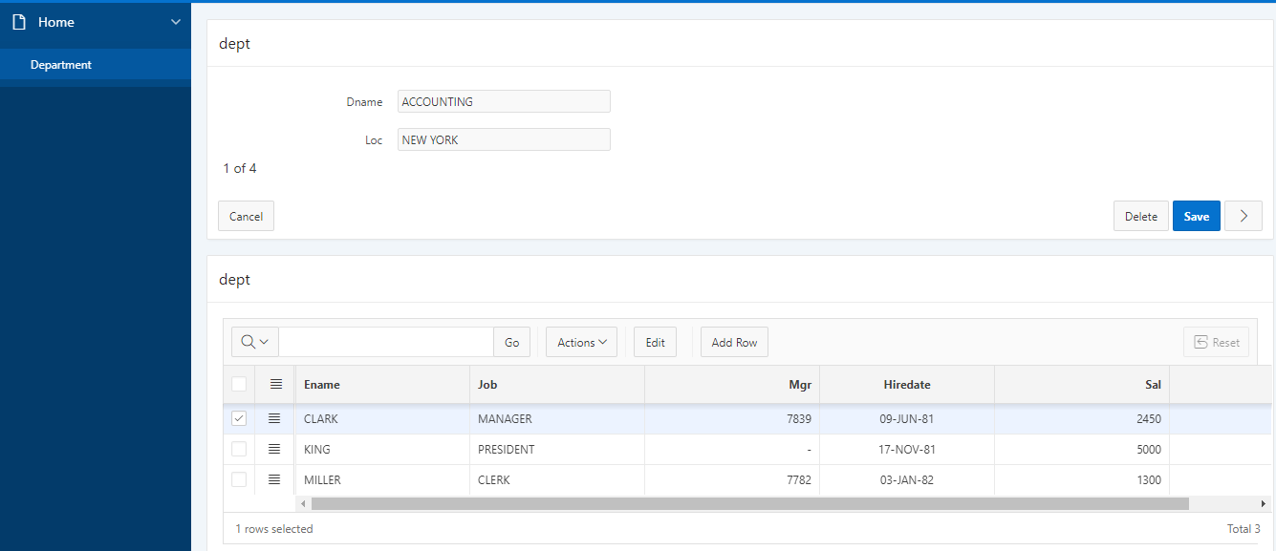
2
1

For numeric and date fields, you can also pre-define date and number format masks, or apply those format masks after generating the initial form. Wizard generated master detail forms also automatically create validations for some columns. Validations are created for columns that are set to NOT NULL in the underlying table and columns of type NUMBER, DATE or TIMESTAMP. Note that validations are not created for columns if the column is set to read-only, either based on the user's selection, or defined user interface defaults.

Creating an Application from Scratch

You can create an application based on a table, query, or drill-down query by selecting Create Application in the Create Application Wizard.

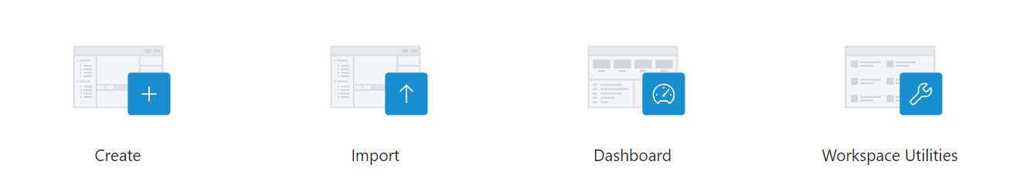

To create an application:
- On the Workspace home page, click the Application Builder icon.
- Click the Create button.
- For Create an Application, select New Application. Then Click Next.

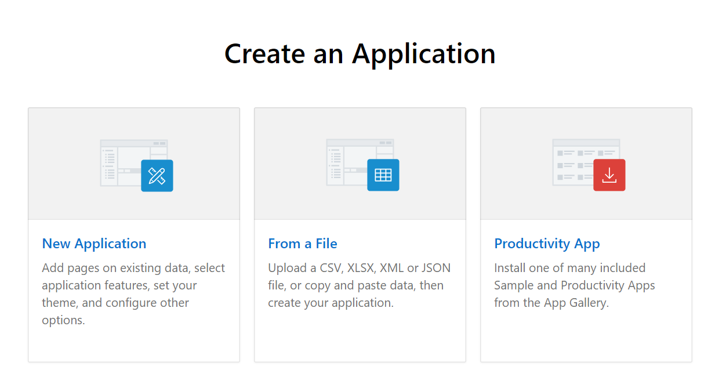

- Enter the following and click Next:
  - Name - Enter a name to identify the application. Enter: HR_Application
  - Theme – leave the default theme. A Theme can be changed at later stage.
  - You could click on Create Application at this stage.

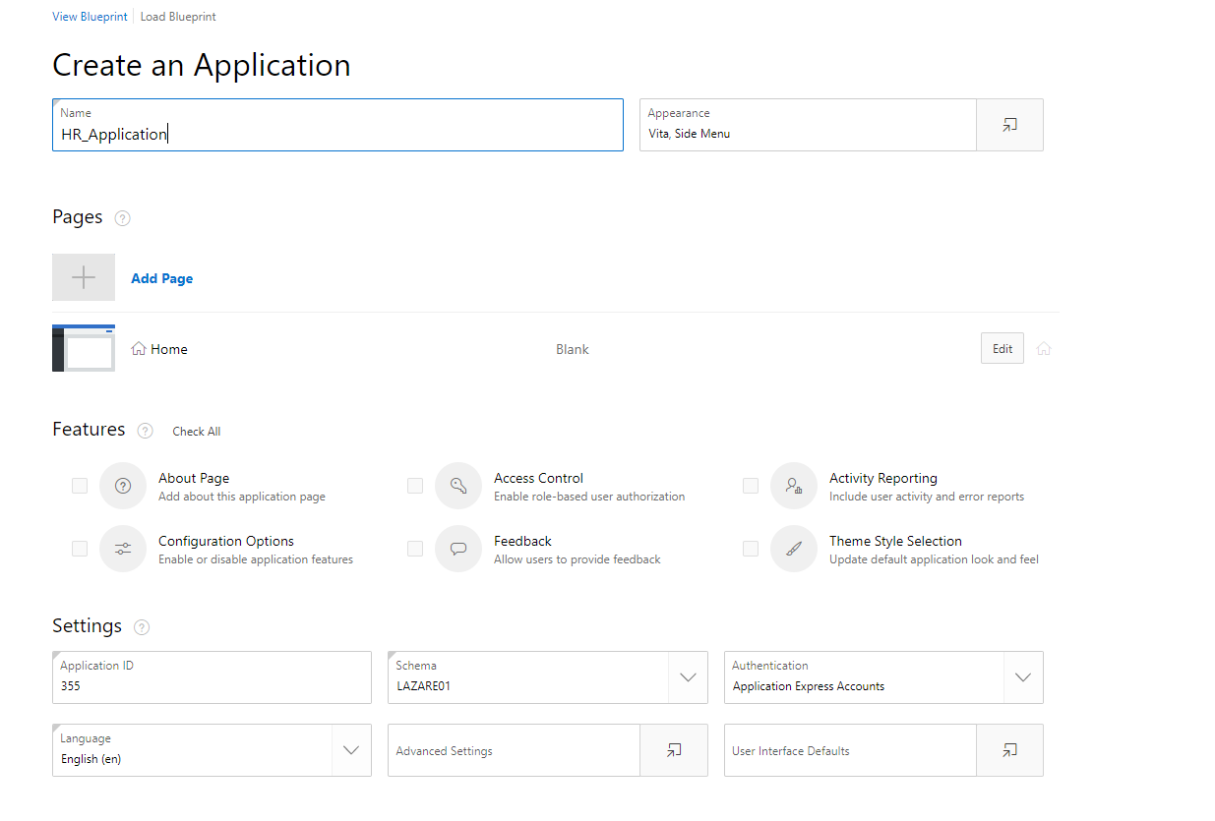
Your Application is now created. If you run it all you will see is a blank canvas, with the label of the application at the top left. Now you are ready to add some content to it, by adding tables that will be used to manage data. In our case these are Dept and Emp tables. You may want to re-run your Scott script to recreate your tables, if you haven't done so already.

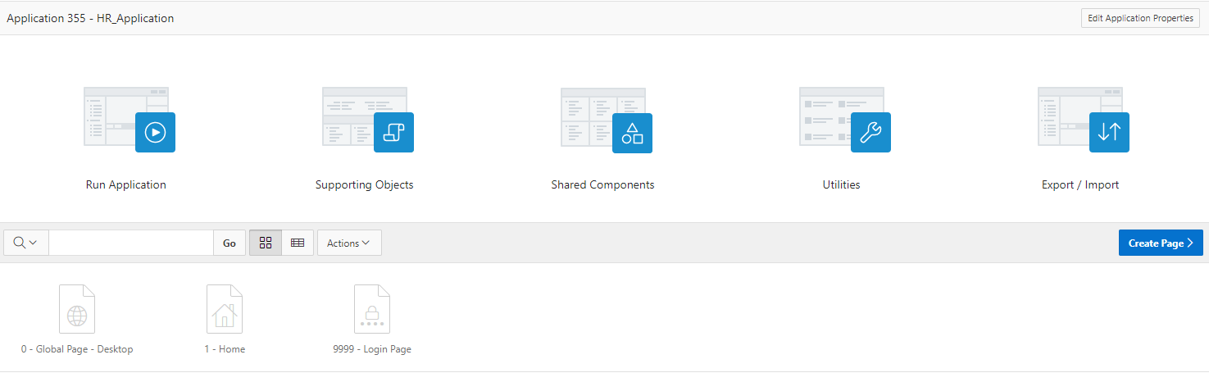

Creating a Master Detail Form

The Create Page Wizard provides support for creating a master detail from two tables. When created using a wizard, the master form on a master detail form page includes buttons that enable the user to move forward and backward within the master result set. While running the wizard, you choose which columns determine the navigation order.

Tutorial Video: https://leedsbeckettreplay.cloud.panopto.eu/Panopto/Pages/Viewer.aspx?id=e1f7fb50-4d14-40c6-ac8c-ab0d00c15970

To create a master detail form using the Create Page Wizard:
- On the Workspace home page, click the Application Builder icon.
- Select the Application and Click Create Page button.
- On Create Page, select Master Detail. This is NEW in Apex 19 – three types of Master Detail forms.
- Choose Stacked option and click on Next
- On Page Attributes for Page Name type in HR Details
- Click Next.
- For Navigation Menu, select how you want this page integrated into the Navigation Menu. Depending upon the option you select, additional attributes appear. Click Next.
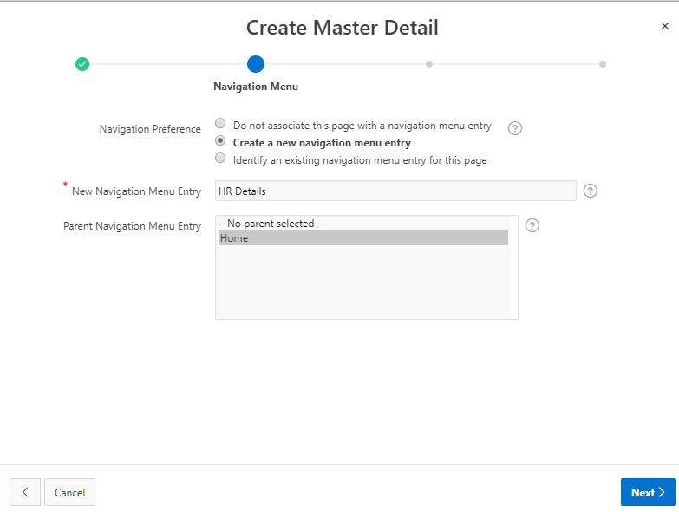
- For Master Source select details as specified on the form below:
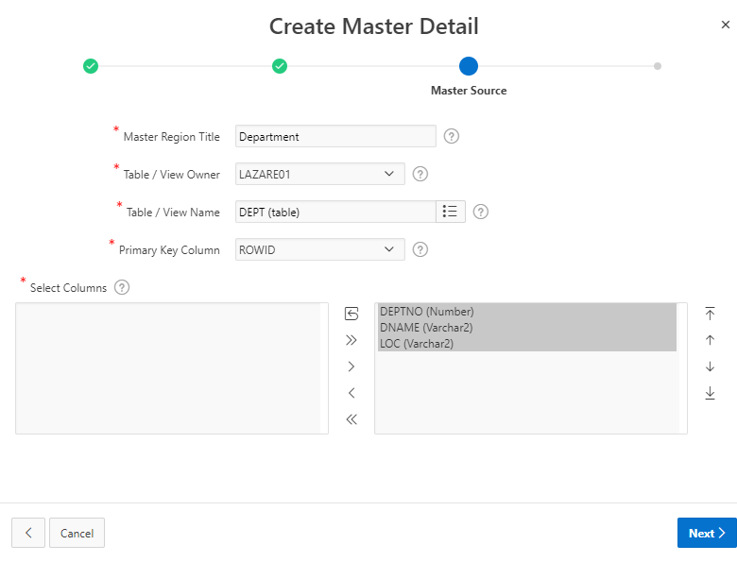
- For Detail Source, specify details as displayed below:
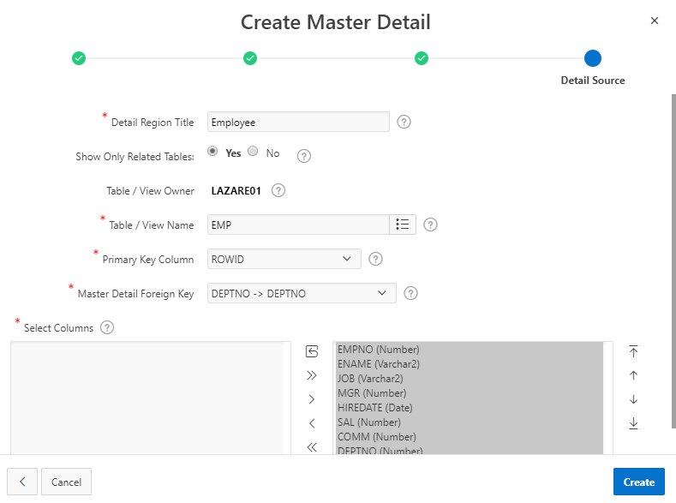
- Click Create. Done. Run the application

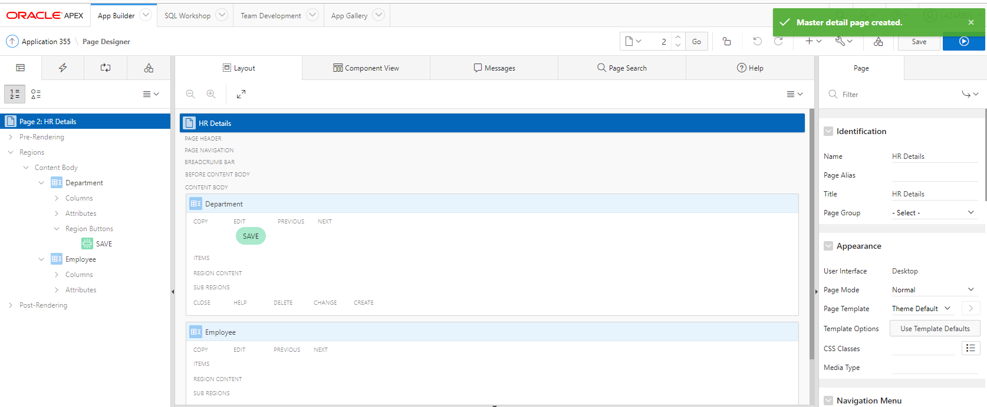
RUN

You may be asked to log in. This is the view you should have.
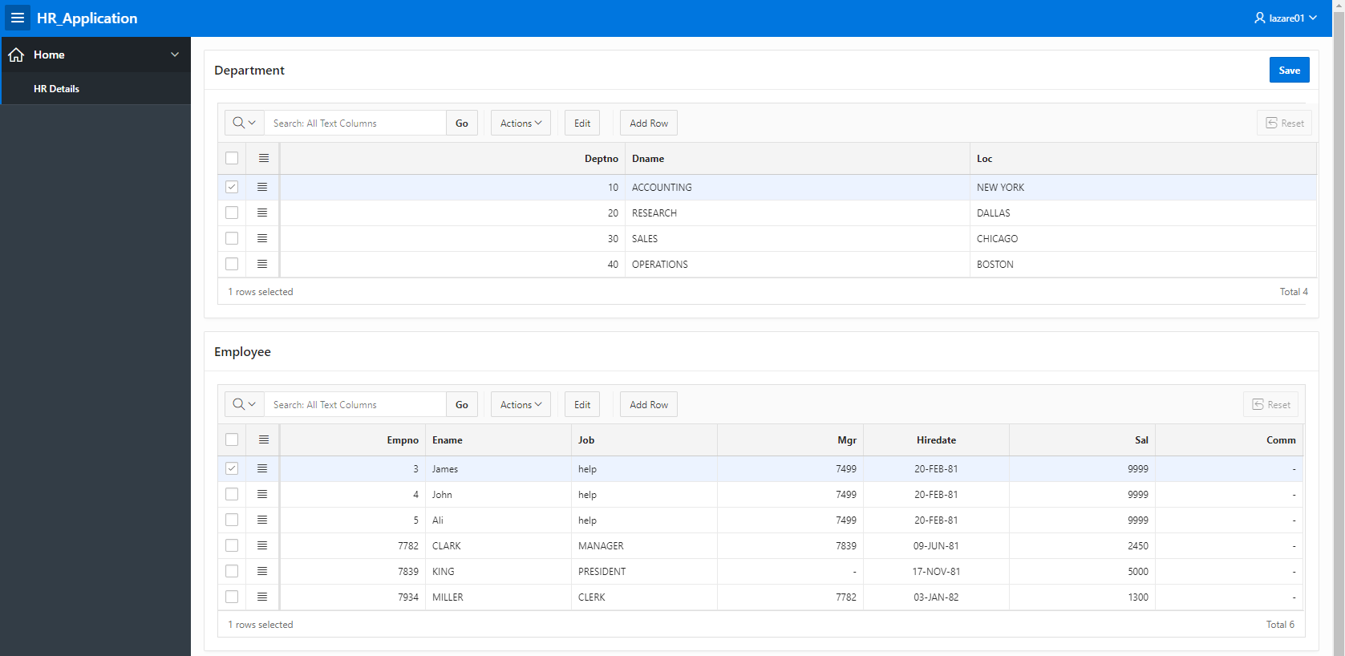

You can also use Oracle Docs to learn how to create different types:
- About Master Detail Forms
- Creating a Master Detail Form Using the Create Application Wizard
- Creating a Side by Side Master Detail Using the Create Page Wizard
- Creating a Stacked Master Detail Using the Create Page Wizard
- Creating a Two Page Drill Down Master Detail Using the Create Page Wizard

https://docs.oracle.com/en/database/oracle/application-express/19.1/htmdb/managing-master-detail-forms.html#GUID-6143A5AE-FCAB-4D7F-8B8C-7EFBE39359FB

Task:
- Insert a new department.
- Add two new employees in the new department.
- Check in Object Browser that the new details are there.

How to use the Form

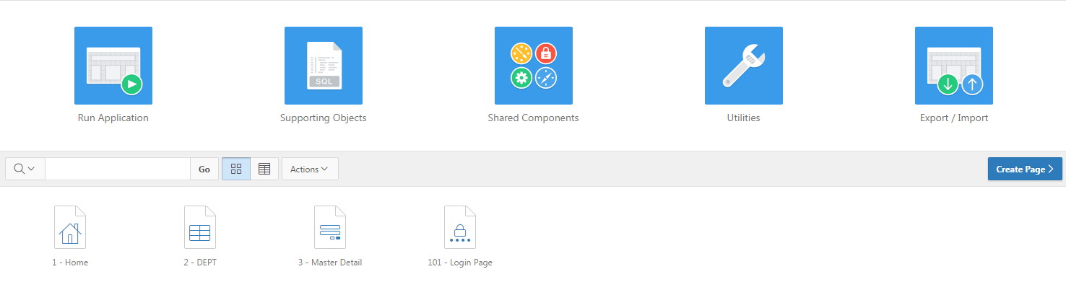

- Click on the Run Button.
- After you log in on the first page you’ll see is the Dept table details. You may need to click on the link: DEPT on the side.
  - by using Add_Row button. Add any record you want then Click on Save button. You may be asked as well to add employee details at this stage.
2
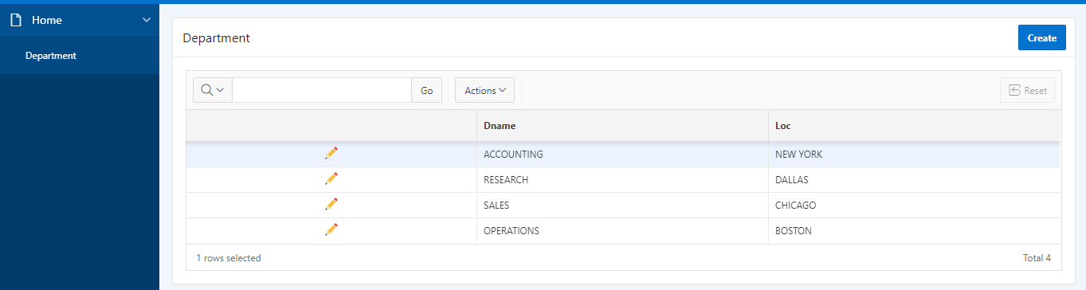

  - You can now add a new record for EMP Detail table by using Add_Row button. Add any record you want then Click on Save button. Again pay attention that empno is not available to add a record.

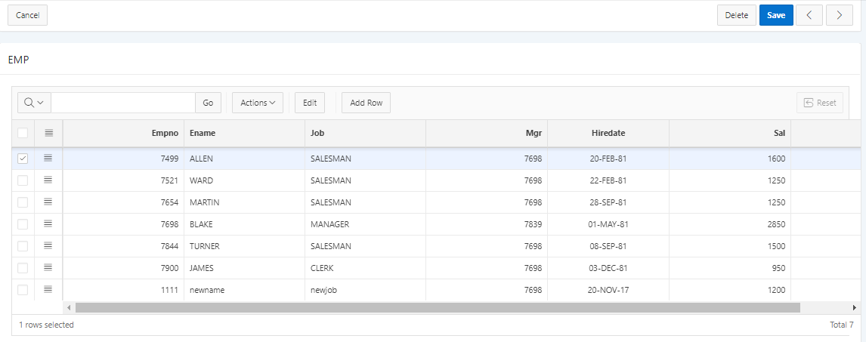
New record
  - Try now to Update salary for any employee to 2000. Save the change.
  - To Delete a detail table (emp) record, make sure you checked record you want to delete and press Delete_Checked.

Creating a Master/Detail – Side by Side Form

To create a single page Side by Side Form using the Create Page Wizard:
- Navigate to the application builder
- Select an application and Click Create Page.
- On Create Page, select Master Detail, choose Side by Side and click on Next
- In the Master Detail Page Name(Value Required) enter: HR Different View.
- For Navigation Menu, select Create a new navigation menu entry and then select Home
- For Master Detail Page Select options shown below:
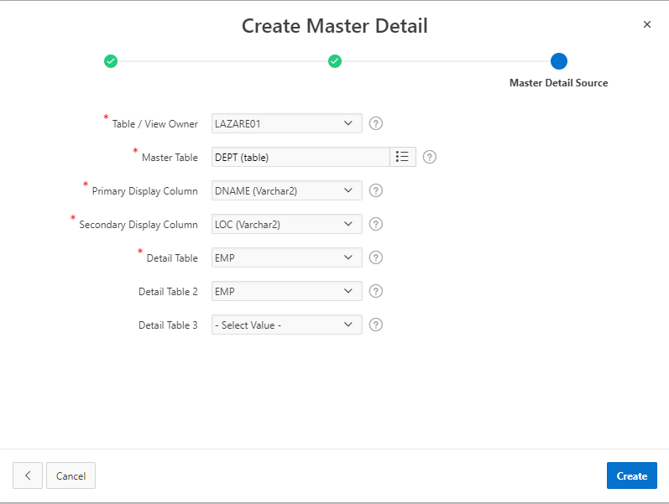

Click on Create and Run the form. The view will look like the one below: 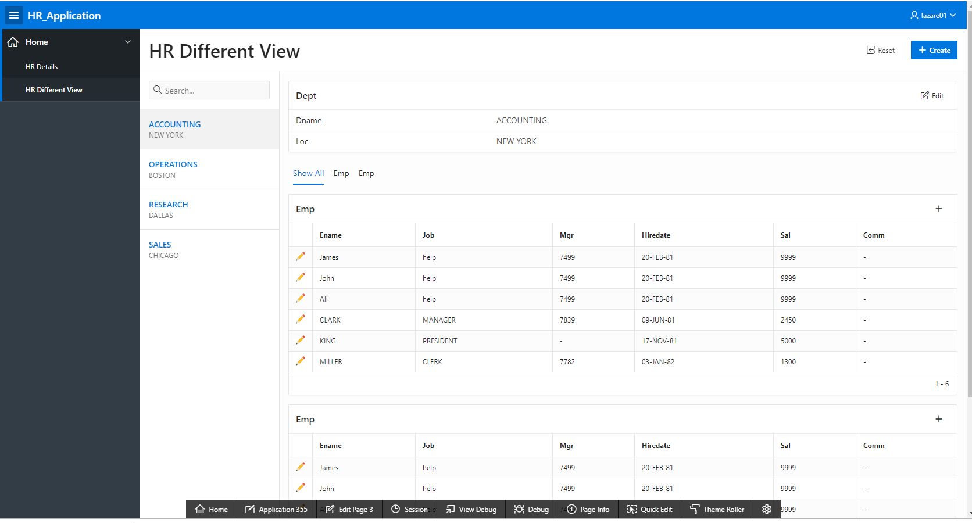

Create on your Master Detail type of page Drill Down
How do to it you can follow instructions here, or watch lecture recording.
https://docs.oracle.com/en/database/oracle/application-express/19.1/htmdb/managing-master-detail-forms.html#GUID-13B701BC-5F10-414E-898A-0399103CCB8D

Developing Reports
When creating a database application, you can include two types of reports: an interactive report or a classic report. The main difference between these two report types is the extent to which end users can customize the appearance of the data through searching, filtering, sorting, column selection, highlighting, and other data manipulations.

To learn more about different types of reports and other options, not discussed in the workbook, please visit
https://docs.oracle.com/en/database/oracle/application-express/19.1/htmdb/developing-reports.html#GUID-A63ECD33-D759-4725-9666-A02719FB35B8

Tutorial Video Reports and Chart:
https://leedsbeckettreplay.cloud.panopto.eu/Panopto/Pages/Viewer.aspx?id=952a9028-8a39-4fd1-8df8-ab0d00c7fc5a

Interactive Reports
To create an interactive report, developers either select a table or provide a SQL statement. Developers can restrict the capabilities available to end users (such as disabling download or support for hiding column). When the end user views the report, report functionality is same across all reports in the application.

When viewing an interactive report, end users can customize how and what data displays. By default, interactive reports include a search bar, an Actions menu, column heading menus, and Edit icons in the first column of each row. Using options on the Actions menu, users can alter the report layout by hiding or exposing specific columns and applying filters, highlighting, and sorting. They can also define breaks, aggregations, charts, group by, and add their own computations. Once customised, the report can be saved as either a private or public report.

The following is an example of an Interactive Report. What it means is that you can view an output form one or more table, and you can drill up or down through the data in the report. This is why it is called Interactive.

To develop an interactive table you can select either a table or provide a SQL statement. In the example below you can see that an SQL statement is used to create this Interactive report above.

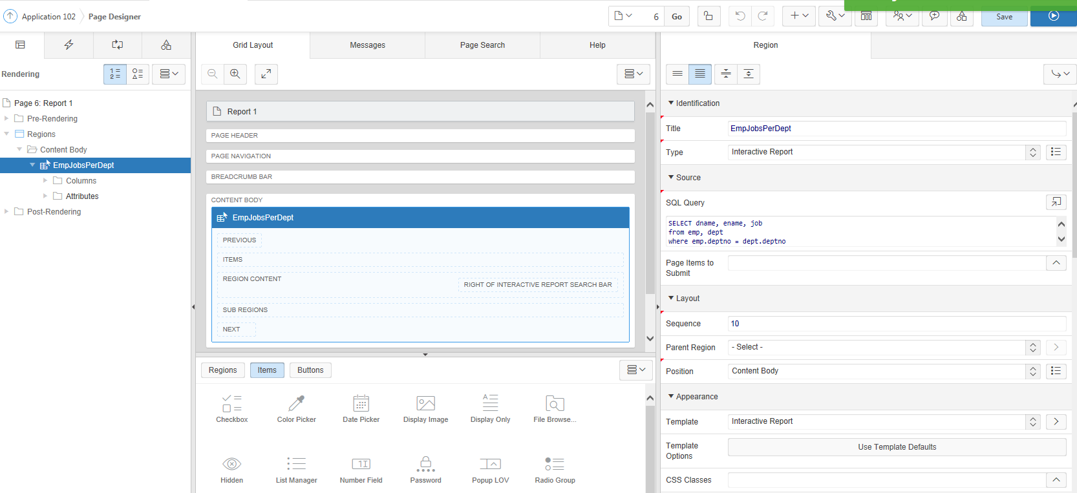

When viewing an interactive report, end users can customize how and what data is displayed. By default, interactive reports include a search bar, an Actions menu, column heading menus, and Edit icons in the first column of each row. Using options on the Actions menu, users can alter the report layout by hiding or exposing specific columns and applying filters, highlighting, and sorting. They can also define breaks, aggregations, charts, group by, and add their own computations. Once customized, the report can be saved as either a private or public report.

See the example below, for employees who are working in the department Research:

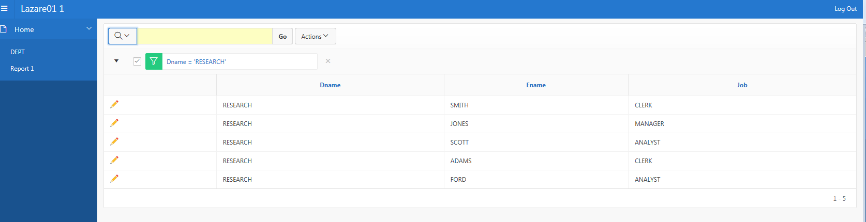
1

How to create an Interactive Report using a Wizard
https://docs.oracle.com/en/database/oracle/application-express/19.1/htmdb/creating-report-create-page-wizard.html#GUID-6AB94A05-66FD-408B-A43E-0FDF5227057A

- Go to Application page for HR_Application and click on Create Button.
- Select Report icon.
- On the Next page select Interactive report. Try to remember the ICON for the interactive report.
- On the next page specify for Page Name: InteractiveReport and click Next.
- On the Navigation Menu page select the second option. In Parent Navigation Menu Entry select Home.

- Click Next
- Type in the following query and don’t forget to validate your query before clicking Next.
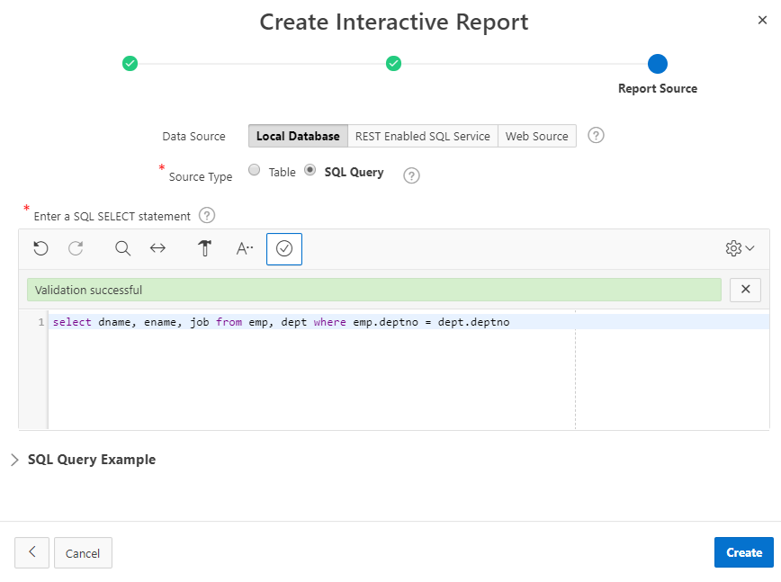

- Validate your query by clicking on the ‘tick’ option, and click on Create.

- Run your Interactive report and sort data accoding to a job, and then filter employee names.
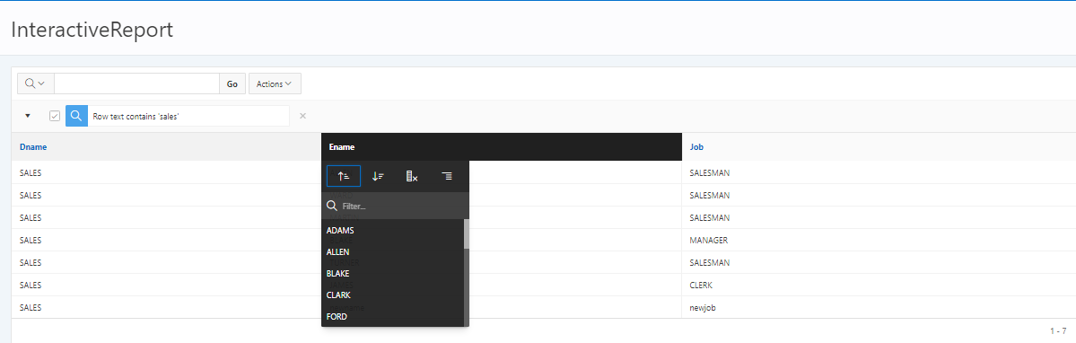

To change name on the Report – if not labelled accordingly from the beginning:

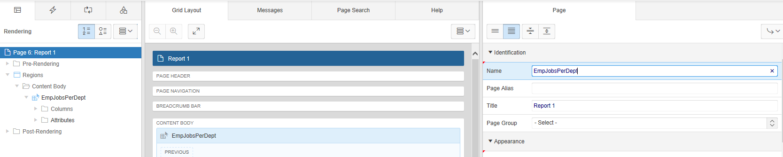

Excersise: Create another Interacative Report of your own choice, using one of the SQL queries you’ve produced previously in SQL&PL/SQL workbook.

Classic Reports
In contrast, except for sorting and simple filtering, end users cannot customize a classic report. The following is an example of a classic report built on top of the same data.

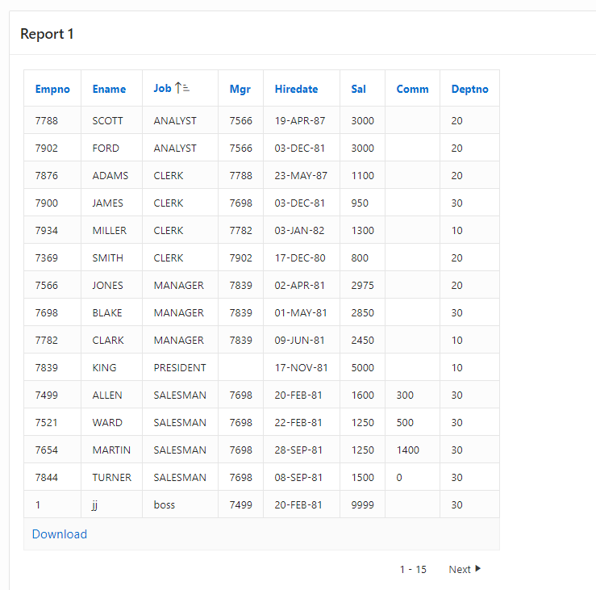
To create a classic report, developers either select a table or provide a SQL statement. Classic reports support general keyword search capability, the ability to specify the number of rows that display, and basic column sorting.

How to create a Classic Report
On the Workspace home page, click the Application Builder icon.
- Select the application e.g HR_Application
- Click Create Page and click Next.
- Click on Report.
- Select a report type - Classic Report and click Next.
- On this page: Leave the default values and Click Next.
  - Follow the on-screen instructions. You could give a name to your report: Classic Report
- On the Navigation Menu page select the second option: Create a new navigation menu entry and highlight HOME page (if you have got one) in the box below.
- Type in the following query:
  - SELECT dname, ename, job FROM emp, dept WHERE emp.deptno = dept.deptno
  - Validate the query and click on Next
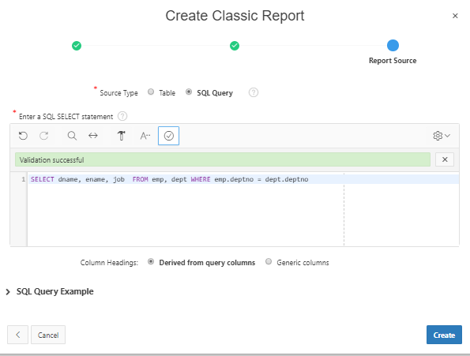
- Confirm your report and click on Create.
- Run your Classic report.Values in your report may look differently, but the colums and layout will be the same:

Editing Column Attributes in Page Designer
You can edit Column attributes to precisely control the report layout. For example, you can use these attributes to alter column headings, change column positioning, hide a column, or control how users can manipulate a column.

To access Column attributes:

View the page in Page Designer. When Page Designer appears.
- In the Rendering tree, locate the region and expand the Columns node.
- The columns appear in the Rendering tree.
- Select a column to edit
- The Property Editor displays the attributes for that column.
- Edit the appropriate attributes. To learn more, see field-level Help.
- To edit the column heading:
  - Locate and expand Heading.
  - Edit the Heading and Alignment attributes.
- To control how users can manipulate a column:
  - Locate and expand Enable Users To.
  - For Enable Users To, select Yes or No to control how users can manipulate the report.
- To save your changes click Save. To save and run the page, click Save and Run
- Page.

Editing Interactive Report At tributes in Page Designer
You can edit report attributes to precisely control how a report works. For example, you can use these attributes to configure pagination, create error messages, configure the Search bar, Action menu, and download options, control if and how users save the report, and configure supported views.

To edit report attributes in Page Designer:
- View the page in Page Designer. Page Designer appears.
- In the Rendering tree, locate the region containing the report.
- Under Region, select the Attributes node.
- The Property Editor displays the report attributes in the Property Editor.
- Edit the appropriate attributes. To learn more, see field-level Help.
- To save your changes click Save. To save and run the page, click Save and Run

Charts

Charts are useful for showing summary data in graphical form. APEX allows you to extract data from your tables and display the results in the form of charts. A variety of chart types are available including Bar and Pie charts.

Suppose you want to display a 2D Pie chart showing the comparison of CASH against CREDIT CD purchases, you can do this using the charting facilities as follows:

Tutorial Video Reports and Chart:
https://leedsbeckettreplay.cloud.panopto.eu/Panopto/Pages/Viewer.aspx?id=952a9028-8a39-4fd1-8df8-ab0d00c7fc5a

Adding a Chart to a New Page
To create a chart on a new page:
- On the Workspace home page, click the Application Builder icon.
- Select your application
- Click Create Page.
- Select Chart and click Next.
- For Region, select Pie and click Next.
- On Page and Attribute page fill in the following:
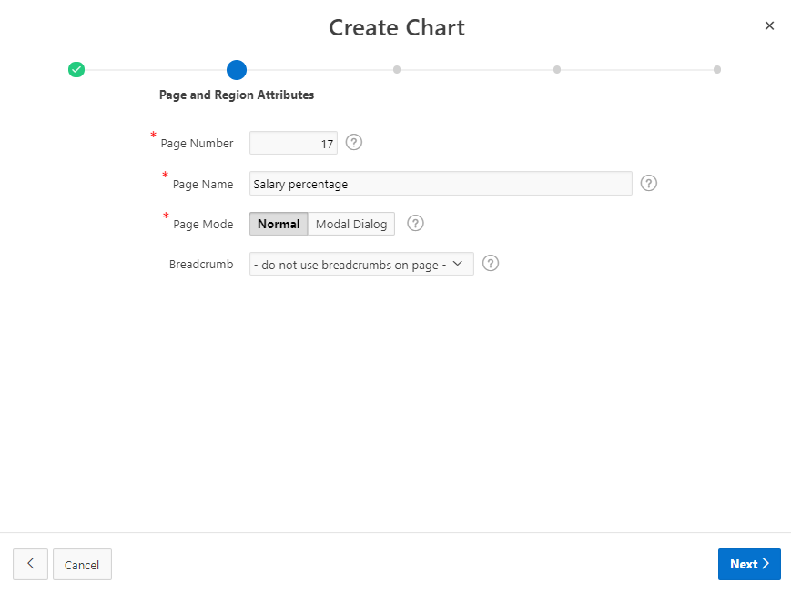
Click Next.
- Select the option Create a new navigation menu entry and highlight HOME page (if you have got one) in the box below and click Next.
- Enter your query. In our example enter:
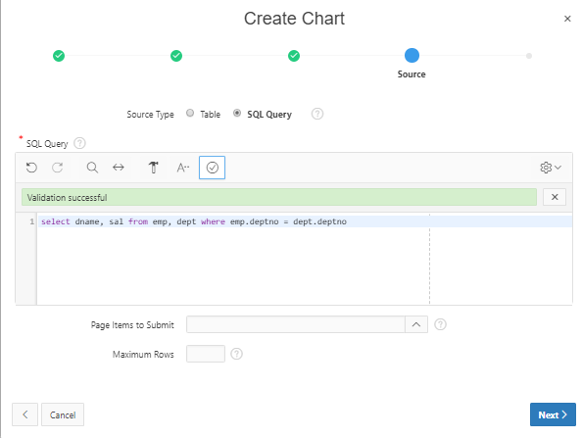
- Validate query and click Next.
- On column Mapping, please select the following:
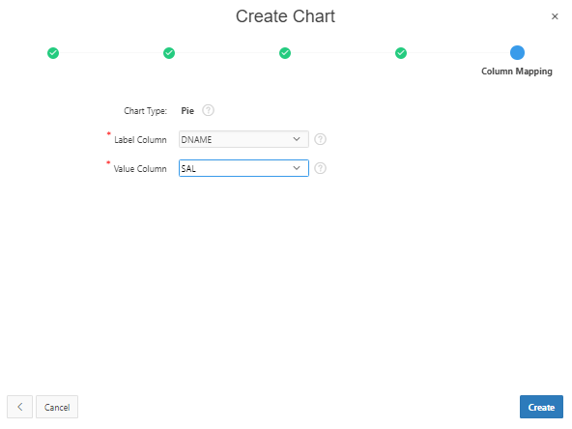
- Click Create and Run your page.

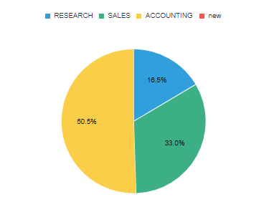

This workbook gives you basic ideas about different interface components in Apex. We suggest you investigate applications such as Sample Report and Charts for further guidance on what can be done by Apex Builder.

In your weekly folder, you’ve also got links to Apex pages on how to create Maps, Calendar, Charts, Reports etc.

5. Creating dashboards – to get you started
Task 1: Install the packaged application – sample reporting. Look through the types of reports and types of output and examples of SQL. Note useful ‘reports’ you could use.

Task 2: Look at sample application – dashboard.
Look at the code, maybe change code, get more ideas of ‘reports’ you might like to create.

Task 3: Create your own dashboard.
See https://www.youtube.com/watch?v=CzlC88y8XWk (Intro to dashboards and charts in oracle)
Create a new application. Add page - Select ‘dashboard’ (you could set up reports here, but I haven’t)
Create application. Run.
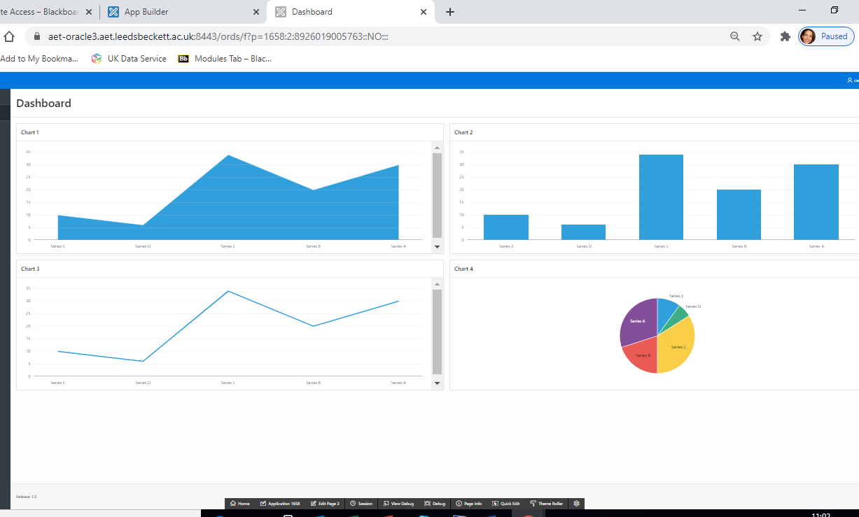
Edit page 2(?)
Click on one of the charts – chart 1. Over on the right you can change:
Identification
The Title – Employees
Type – classic report
Source
Location – local database
Type – SQL Query
SQL Query - SELECT * FROM emp

On Chart 2 – change:
Identification
The title – Employees by Department
Type – leave
Click on the series 1 on the left and change
Location – local database
Type – SQL Query
SQL Query - SELECT COUNT(*), deptno FROM emp GROUP BY deptno

Click on series/New for the chart
Scroll on the left to column mapping, enter as below

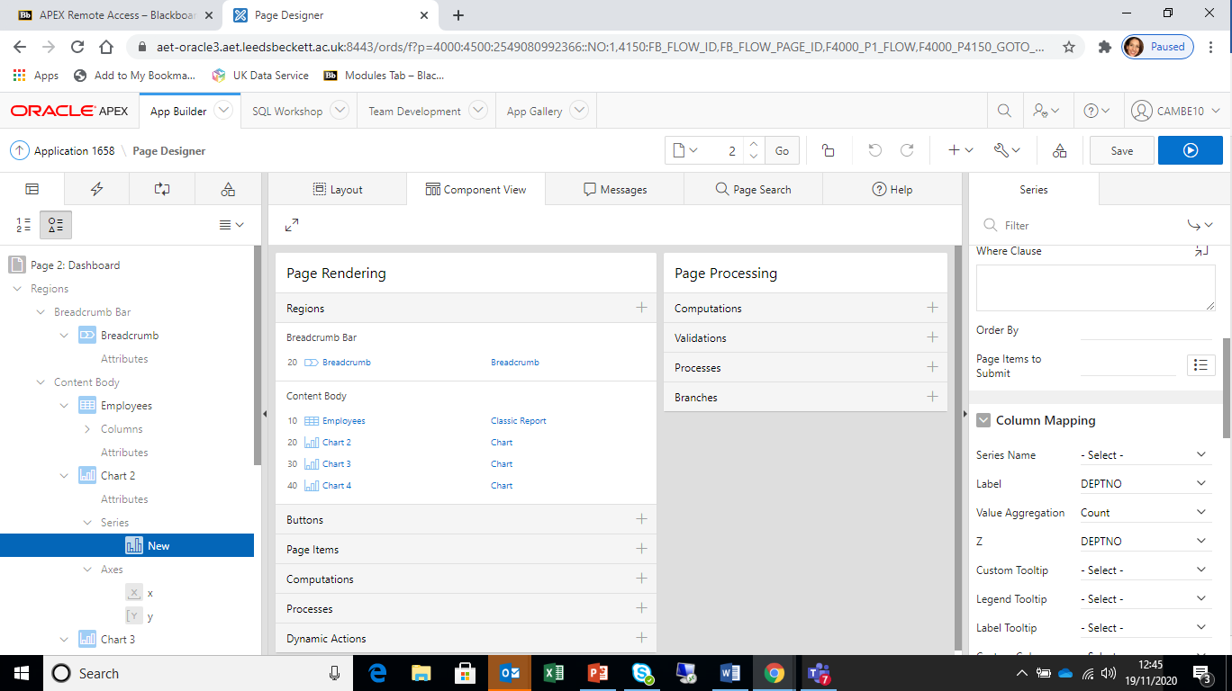

Run the application
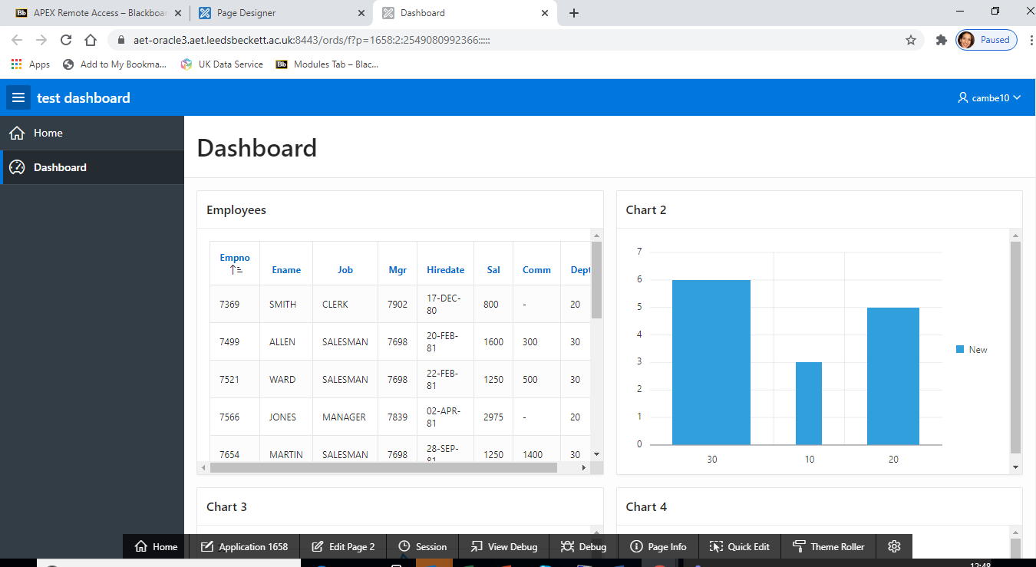

Understand a ‘series’ as a “A data series is a row or column of numbers that are entered in a worksheet and plotted in your chart, such as a list of quarterly business profits.”

6. Interesting Apex AB Develop applications
Visit https://apex.oracle.com/pls/apex/f?p=411:5:::NO:::

7.Plug ins
Visit https://apex.world/ords/f?p=100:1::::::

8. Managing Database Application Components
Review the following using oracle document pages

How to create multiple users and authorization scheme

Tutorial instructions: https://leedsbeckettreplay.cloud.panopto.eu/Panopto/Pages/Viewer.aspx?id=871eac83-5aa6-43cc-9ff3-ac7d0143e15d

Creating Users visit for documentation:
https://docs.oracle.com/en/database/oracle/application-express/19.1/aeadm/managing-users-in-a-workspace.html#GUID-DF7FEC59-E25F-4DC9-88F0-DBE1ADADA8BC

Creating Authorization schema visit for documentation: https://docs.oracle.com/database/apex-18.1/HTMDB/providing-security-through-authorization.htm#HTMDB12004

Creating Maps, Calendars and Charts
Visit:
https://docs.oracle.com/en/database/oracle/application-express/19.1/htmdb/managing-database-application-components.html#GUID-E7598ABE-5077-4A1F-A3F9-1C89EE2B2CE8

